|  |
| --- |
| Enterprise Resource Planning (ERP) |
| Krishibid Feed Limited (KFL) |
| PREPARED BY : KG ERP Team |

Table of Contents

Objective 3

Krishibid 3

Business Process of GCCL 4

Inventory management types 5

Raw Materials 5

Works-in-progress inventory 5

Finish Goods 6

Maintenance, Repair, and Operations (MRO) goods 6

Sales 6

Conclusion 8

# Objective

ERP, or Enterprise Resource Planning, is a suite of integrated business software applications (often called modules) that allow companies to track and manage data and even automate some business functions, including Human Resources.

# Krishibid Feed Limited (KFL)

Krishibid Group is rapidly expanding its operations by lunching diversified new business units. An automatic feed mill has been set up to manufacture poultry, cattle and fish feeds of different types. It markets high quality feeds. The mill has a capacity of manufacturing 9 ton floating and sinking feeds per hour. It is located at Nishinda Bazar of Bhaluka, Mymensingh on Dhaka-Mymensingh High Way. The mill is producing both floating and sinking feeds for fish and shrimps. It production poultry feed of all kinds. Besides, it will produce quality cattle feeds. All environmental protection is ensured within and around the mill area. Krishibid Feed Mill is equipped with all modern processing and production machineries and hence guarantees supply of quality products to its customers. Krishibid Feed Limited (KFL) is a member of Feed Industry Association of Bangladesh (FIAB). Planning is going on toenchnace the production capacity of the mill in the near future.

# Business Process of KFL

**Fig: 01 Business Process of GCCL**

# ****Inventory management types****

**Inventory** is the collection of unsold products waiting to be sold. Inventory is listed as a current [asset](https://investinganswers.com/node/2278) on a company's [balance sheet](https://investinganswers.com/node/1083). Inventory is commonly thought of as the finished goods a company accumulates before selling them to end users. But inventory can also describe the [raw materials](https://investinganswers.com/node/6329) used to produce the finished goods, goods as they go through the production process (referred to as "work-in-progress" or WIP), or goods that are "in transit."

There are generally five reasons companies maintain inventories:

* To meet an anticipated increase in demand;
* To protect against unanticipated increases in demand;
* To take advantage of price breaks for ordering raw materials in bulk;
* To prevent the idling of a whole factory if one part of the process breaks down; and,
* To keep a steady stream of material flowing to retailers rather than making a single shipment of goods to retailers.

Typically, inventory types can be grouped into four categories: (1) Raw materials, (2) Works-in-process, (3) Finished goods, and (4) Maintenance, Repair, and Operations (MRO) goods.

## **Raw Materials**

**Raw materials** are any items used to manufacture components or finished products. These can be items produced directly by your business or purchased from a supplier. For example, a crop care and seeds making business could purchase raw materials such as pesticide, insecticides, fungicides & herbicides, and decorative packet.

## **Works-in-progress inventory**

**Works-in-progress inventory** refers to unfinished items moving through production but not yet ready for sale. In the case of a crop care and seeds making business, work-in-progress inventory might be crops that are wet and unpackaged.

# **Finish Goods**

Finish goods are products that have completed the production process and are ready to be sold the seeds themselves. Finished goods are indeed the final products obtained after the application of the manufacturing processes on the raw materials and the semi-finished goods discussed above in the article. They are saleable and their sale contributes fully to the revenue from the core operations of the company. Regarding the level of finished goods inventory, there are two types of industries that we need to look at. First, we would take the industries in which the finished goods are mass produced and the sale happens after the production. For a company in such an industry, the correct approach is to maintain the finished goods inventory in a similar manner as the raw material inventory is maintained i.e. at an optimized level as per the demand in the market.

## **Maintenance, Repair, and Operations (MRO) goods**

**Maintenance, repair, and operations (MRO) goods** are items used to support and facilitate the production of finished goods. These items are usually consumed as a result of the production process but aren’t a direct part of the finished product. For instance, disposable molds used to manufacture seeds packet would be considered MRO inventory.

# Sales and Distribution

Sale is an important activity in an organization. Strategic sales management involves effective and efficient handling of systems and processes towards successful sales. An effective sales process is key for closing more sales and generating more repeat business. For this careful management, following is required. KFL have some sales process in their business strategy.

* **Sales Force- An efficient and effective Salesforce is required for enhancing the sales productivity of an organization.**
* **Sales territories - These are important to get good customer coverage target achievement with more sales, lower costs and performance evaluation.**

KFL maintain a Central Deport in their central area. After that Product will preserve some other depot which hold like deport A, deport B, depot C. Respective Area Manager (AM) dealings with customers for the product. Order Taken by Dealers from the customers. Order Process will pending for the further approval and checked by the Depot In charge / Area Manager (AM) / Supportive Territory Manager (TM) after that order will forward to the immediate depot just Like depot A, depot B, depot C.

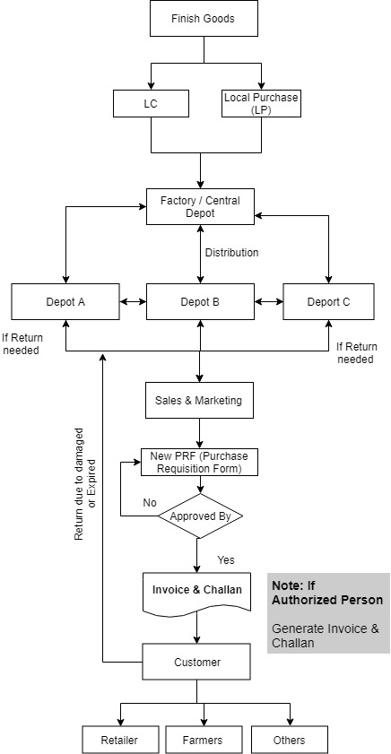

**Fig: 02 Sales Process of KFL**

# Conclusion

Necessary attribute detail has been given based on the requirements and understanding from the user end. But IT Team must analyze and improvise if there needed more attributes and condition to manage the KFL ERP more efficiently in KG.